Design Document
Version 3
Fontys University of Applied Science Software
Project Plan Individual project:

Tutor: Tim Kurvers & Maja pesic
Student: Mohammed Al Harbi
4089553

Contents
Contents 2
CI setup 3
Design decisions 3
C4 Diagram 5
Versioning table 9
Sprint 4 burn-down chart 10
ALL REFERENCES 11

CI setup

The following is the diagram that shows how CI is set up for Henaknowledge:

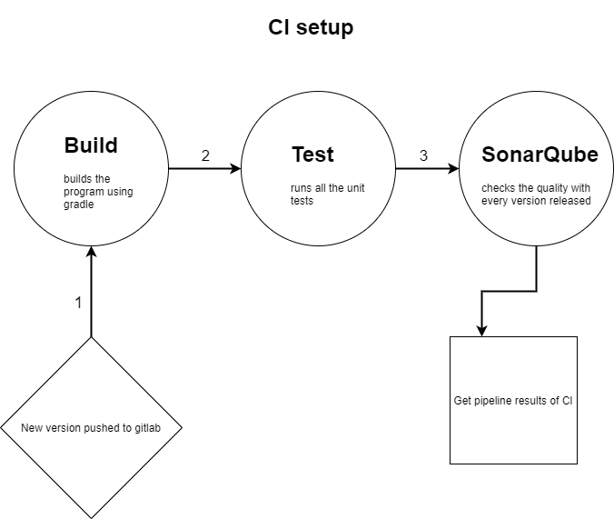

Design decisions

I read a blog to help me get more insights about what possible design decisions I might take and what they are in first place. I understood that they are 3 main points I need to consider while designing, my previous experience, my references and my intuition. All three combined would make that sound in my head that tells me to take a specific design based on them. Thus, I decided to ask actively for feedback on the UX for frontends I develop to have good experience help me take better decisions in the feature for any kind of project I might be working on.

Ref. (Shir, 2018)

I showed one of the teachers (Roopali Gupta) the Henaknowledge platform (Sprint 4/ Version 1.0.2 more information shown in the versioning table) and received very useful feedback regarding the design decision that were taken poorly and how could I improve them.

- Here is a list of the feedback I received from the teacher:

1- Landing page can be profile for now
2- align either everything in login in the center or all left
3- text under Henaknowledge platform should be in one line to make it consistent with the title
4- by default the list of teachers or students should follow an order for example an alphabetical order so that users
can eventually find who they look for
5- fire, banned are strong organizational words, use more positive ones. remove, access has been removed.
6- code should be generated only after clicking on a redeem points point for instance.
7- check whether a teacher can have multiple specializations and accordingly to it choose if when creating a teacher to use multiple
checkboxes or a dropdown to specify the specialization(s)
8- have a sort option to allow the student to sort teachers in particular order
9- font of search should be a little bigger so that the student can see what they searched for properly
10- improve the structure of the auto generated email, for example to have this is an autogenerated email please do not reply ..etc
11- change the words used in banning the user from Ban to something like your access have been removed if you think
it was a mistake please contact blabla@Gmail.com ..etc

- An example of a decision I took in terms of designing:
- After user enters wrong username or password I notify the user with a text and Notification popup on the left of the screen.
Link: https://www.npmjs.com/package/react-notifications

DOT framework methods used:
- Document analysis
- Peer review
- Prototyping

C4 Diagram

System context: C1
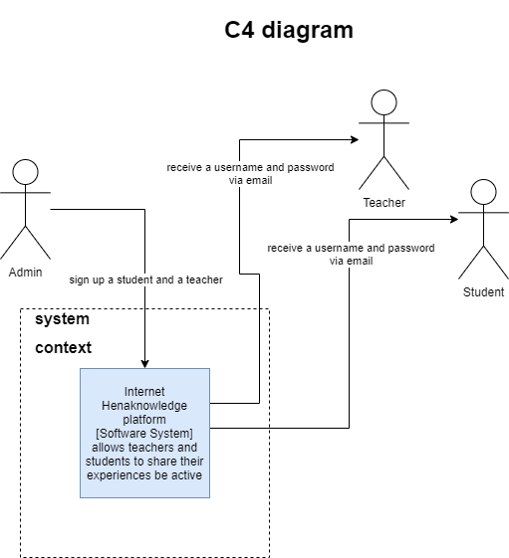

Container : C2
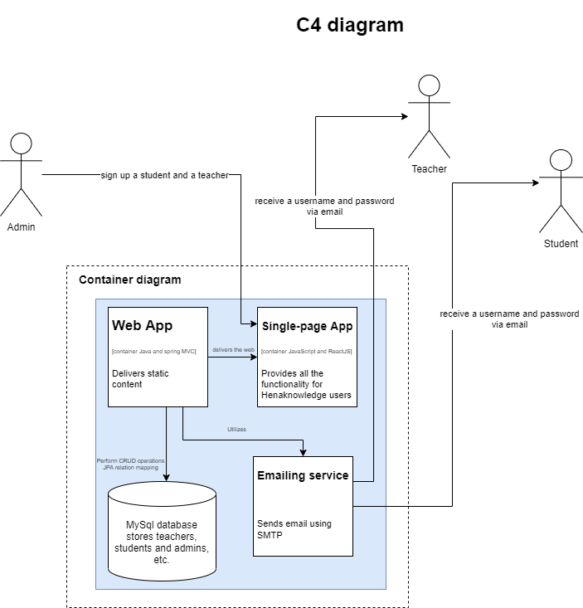

Component : C3

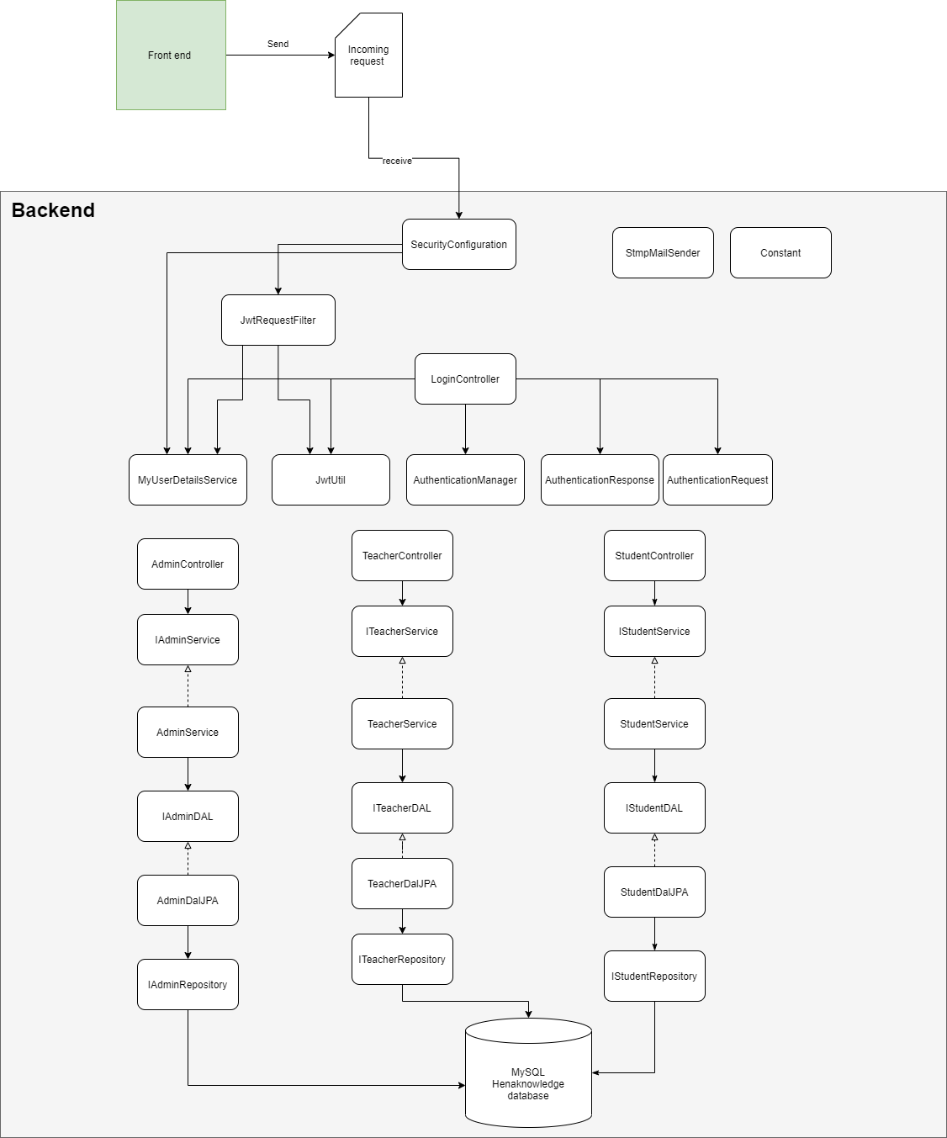

Class diagram : C4
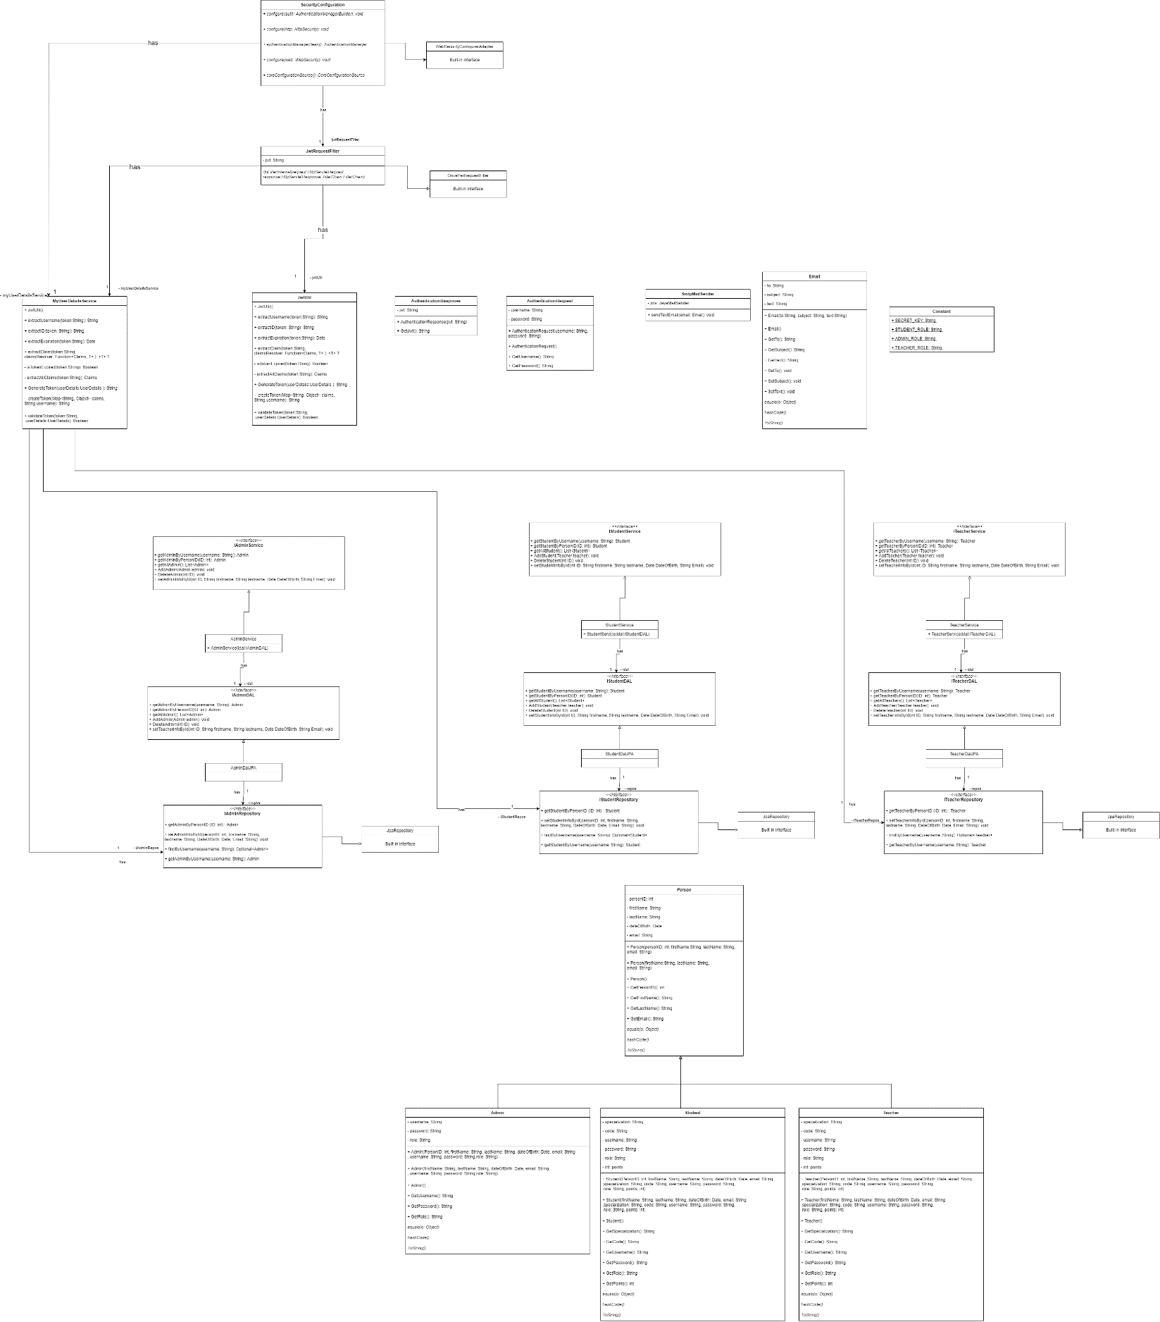

Versioning table

Sprint/Version | Functionality/ differences
Sprint 2 / Version 1.0.0 | Crud operations(JPA), no login, no authorization, no authentication.
Sprint 3/ Version 1.0.1 | Crud operations(JPA), login, authentication, no authorization, no jwt.
Sprint 4/ Version 1.0.2 | Crud operations(JPA), login, authentication, authorization, jwt generate, extract information from jwt in frontend ,email sending.

In the git repository there is a demo videos folder. I recorded a video in which the application had the login functionality but without JWT named as:

(“Frontend login no authorization.mp4”)

There is also another two videos that show up-to-date the project with JWT implemented named as:

(“Demo_authentication_authorization.mp4”)

(“Functionalities.mp4”)

Sprint 4 burn-down chart
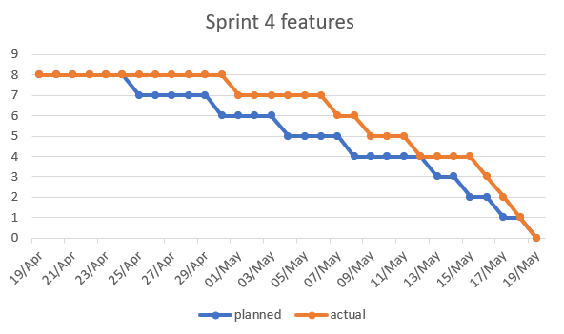

ALL REFERENCES

Npm: React-notifications. (n.d.). Npm.
https://www.npmjs.com/package/react-notifications
Shir, G. (2020, October 16). How Do You Make Design Decisions? Marvel Blog. https://marvelapp.com/blog/make-design-decisions/

